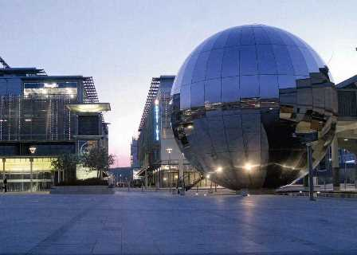

**UK CFS/ME Research Collaborative conference**

**13 & 14September 2017 @ future inn, Bristol city centre**

**abstract form**

|  |  |
| --- | --- |
| **TITLE:** |  |
| **AUTHOR(S):**  (Please underline presenting author) |  |
| **INSTITUTION:** |  |
|  | |
|  | |

**Please return form by email to anna@actionforme.org.uk**

**Deadline: 09:00 Friday 30 June 2017**

**Register for the conference at www.cmrc2017.eventbee.com**

